**Multifunctional trip computer XS**

**Notice:**

Working voltage of this product: 11V-18V (12V/ 200mA)

After the product is powered on, select the language first, and then select the system (OBD/GPS). After 5 seconds of no operation, it will automatically enter the last selected system.

**Appearance function:**

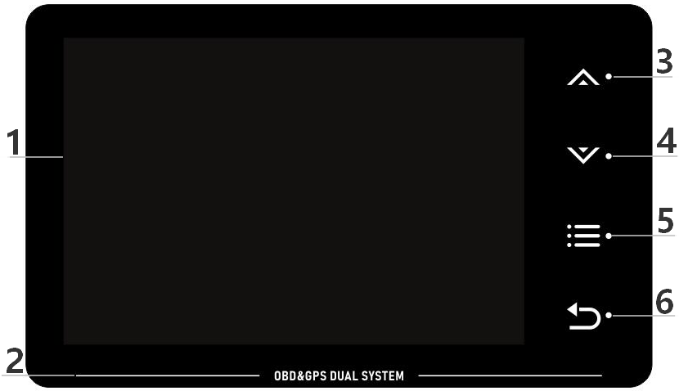

1. TFT LCD Screen
2. **Atmosphere light:** With the change of engine speed or vehicle speed (you can choose to turn off in the setting item)
3. ** Touch for 1 second:** ①Switch the function display on the left ②Switch the setting items in the setting menu

**Touch for 2 seconds:** ①switch the color-changing atmosphere light color ②turn off the atmosphere light

1. ** Touch for 1 second:** ①Switch the function display on the right ②Enter the setting item and move the option

**Touch for 2 seconds:** ①Switch the color of the fixed atmosphere light

1. ** Touch for one second:** ①Switch the display interface ②Lock the setting items

**Touch for 2 seconds:** ① Enter the setting menu ②After the parameter value is adjusted, press and hold to save and exit

1. ** Touch for one second:** return

**Touch for 2 seconds:** Slope gauge display interface to calibrate the slope

**Show function abbreviations:**

ECT engine temperature VLT voltage display FUE fuel consumption display

AVG average fuel consumption RPM Engine speed IM System time

MIN Driving time DIS Driving distance MAP Intake pressure OIT Oil temperature A/F Air-fuel ratio TCP Turbo pressure

PSI Turbo pressure RTC Satellite time ASL Altitude DIR Driving direction TPS Throttle valve KM/L Fuel consumption unit

IAT Air Temperature ELD Engine Load CVT Transmission Temperature ODO Total Mileage GPS Satellite Status

|  |  |  |  |  |  |  |  |
| --- | --- | --- | --- | --- | --- | --- | --- |
| P9_0001_电压P9_0001_电压 | Voltage | P9_0006_瞬时油耗 | Fuel consumption | P9_0026_行驶方向 | Driving direction | P9_0021_行驶距离 | Driving distance |
| P9_0002_水温 | Water temperature | P9_0007_平均油耗 | Average fuel consumption | P9_0015_机油压力 | Hydraulics pressure | P9_0022_行驶时间 | Driving time |
| P9_0003_机油温度 | Oil temperature | P9_0008_引擎负载 | Engine load | 17 | KM/L | P9_0023_转速 | Rotating speed |
| P9_0004_变速油温 | Gearbox temperature | 20 | Intake air temperature | P9_0017_海拔 | Altitude | 14 | Air-fuel ratio |
| P9_0005_涡轮压力 | Turbo pressure | 6 | Total mileage | P9_0018_时间 | Chock | 18 | Vehicle speed |
| P9_0027_大气压力 | Intake pressure | 9 | Satellite status | 19 | Throttle |  |  |

**Setting menu:**

**Touch for 2 seconds** to enter the setting menu, **touch for one second** to select the setting item; after entering the setting item, **touch for one second** to adjust the parameter value, **touch for 2 seconds** to save and exit

**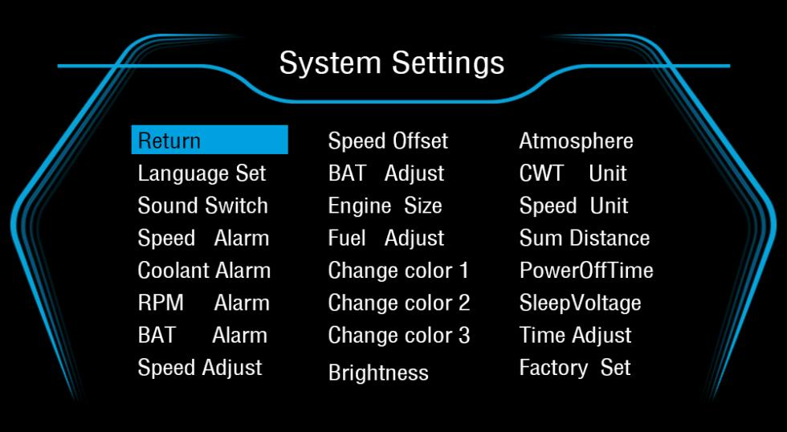**

**Select system language:** English, Simplified Chinese, Traditional Chinese, Thai, Japanese, Korean, Russian, Arabic,Malay, Spanish, German, French

**System sound setting: ON** turns on the alarm sound / **OFF** turns off the alarm sound

**Overspeed reminder:** alarm when the vehicle speed exceeds the set value (the default parameter value is 150km/h, and the setting range is 5-200km/h)

**Engine temperature alarm:** alarm when the water temperature exceeds the set value (the default parameter value is 120°C, and the setting range is 50-200°C)

**Engine speed alarm:** alarm when the speed exceeds the set value (the default parameter value is 6000R/min, and the setting range is 1000-8000R/min)

**Voltage alarm setting:** alarm when the voltage is lower than the set value (the default parameter value is 10.5V, and the setting range is 10.0-15.0V)

**Speed error adjustment:** If there is an error in the speed values

displayed by the product and the car dashboard, the product parameter value can be adjusted (for example: the car shows 100Km/H, the product shows 105Km/H, and the parameter value can be adjusted to 102%)

**Speed zero setting:** The speed does not return to zero after the car is turned off (for example: the product displays 5Km/h, you can adjust the parameter value to 6km/h, and the speed will return to zero)

**Voltage error adjustment:** If there is an error in the voltage displayed on the product and the car dashboard, you can fine-tune the product parameter value (for example: when the product voltage is 0.2V higher than the car voltage, adjust the parameter value to 98%)

**Engine displacement setting:** If there is an error in the displacement between the product and the car, it can be fine-tuned according to the displacement of the car(For example: if the car displacement is 3.6 liters, adjust the parameter value to 3.6L)

**Fuel consumption data adjustment:** If there is an error in the fuel consumption of the product and the car, you can fine-tune the product parameter values(For example: when the fuel consumption of the product is 0.2L higher than that of the car, adjust the parameter value to 98%)

**First color adjustment:** the speed color of the main screen (multiple colors available)

**Second color adjustment:** the color displayed on the left (multiple colors available)

**Third color adjustment:** the color displayed on the right (multiple colors available)

**Backlight brightness setting:** "AUTO" is automatic light-sensitive, "1-8" is manual adjustment range

**Atmosphere light setting:** **RPM** speed control color-changing atmosphere light **SPEED** vehicle speed control color-changing atmosphere light **RED** atmosphere light **GREEN** green atmosphere light **BLUE** blue atmosphere light **YELLOW** yellow atmosphere light **BLUE-GREEN** blue-green atmosphere light **PURPLE** purple atmosphere light **OFF** turn off the atmosphere light

**Temperature unit setting:** **℃** Celsius **℉** Fahrenheit

**Speed unit setting: KM/H** kilometers **MPH** miles

**Statistical mileage adjustment:** the total mileage of the product and the car is synchronized

**Shutdown delay setting:** the default parameter value is 10 seconds, and the setting range is 5-300 seconds

**Shutdown voltage setting:** When the product cannot be shut down, the parameter value can be adjusted to 13.2V/13.6V(auto start-stop or gasoline-electric hybrid cars are adjusted to COM mode)

**System time adjustment:** The default time zone is GMT+8 (Beijing time), and the adjustment range is 30 minutes/time

**Restore factory settings:** ** Touch for one second** to save and exit, that is, restore factory settings

**Toggle atmosphere light**

Touch any display interface for ** 2 seconds** to switch the color of the atmosphere light

**Slope gauge Calibration**

Switch the product to the display interface of the slope gauge first, then place the product horizontally, and ** touch for one second** to complete the calibration

**Time Calibration**

** Touch for 2 seconds** to enter the setting menu, and ** touch for 1 second** to switch to the setting item "System Time Adjustment". ** Touch for one second** to adjust, the adjustment range is 30 minutes/time, ** touch for 2 seconds** to save and exit

**Performance Testing**

**Acceleration test:** the acceleration time required for the vehicle speed from 0 to 100km/h, this function is a dynamic test for the car

**Brake test:** after the vehicle speed exceeds 100km/h, the time and distance used in the braking process, this function is the performance test of the brake

**Fault diagnosis settings**

**Scan fault codes:** scan the car for faults and display fault information

**Clear fault code:** When the car has a fault code display, ** touch it for one second** to clear the fault code

**OBD system FAQ:**

**1. No display on the screen, no power supply**

Please check whether the OBD cable is damaged, or replace the car for testing

**2. The product is powered on, and the screen only displays the voltage**

Please switch to the GPS system (within 5 seconds after the product is powered on, ** touch for one second** to select the GPS system)

[HUD products are only suitable for OBD2 and EOBD (vehicles produced after 2008, only start to use OBD2 and EOBD)]

**3. Inaccurate speed**

①Please check whether the speed unit is correct kilometer KM/H mile MPH (please refer to the speed unit setting in the setting menu)

②If the speed unit is correct, the speed can be fine-tuned (please refer to the speed error adjustment in the setting menu)

**4. Unable to shut down**

Enter the system settings, switch to the shutdown voltage setting, and adjust the parameter value to 13.2V/13.6V (the product will automatically shut down after three minutes of turning off the car)

**5. When automatically start and stop or the gasoline-electric hybrid vehicle is running, the product are automatically shut down**

① Enter the system settings, switch to the shutdown voltage setting, and then adjust the mode to COM

② Enter the system settings, switch to the shutdown delay setting, and adjust the parameter value to 300 seconds (the product will automatically shut down after the car is turned off for five minutes)

③Please switch to the GPS system (within 5 seconds after the product is powered on, ** touch for one second** to select the GPS system)

**6. Operation errors caused the product to crash**

①Enter system settings, switch to restore factory settings, ** touch for one second** to save and exit

②Please switch to the GPS system (within 5 seconds after the product is powered on, ** touch for one second** to select the GPS system)

**GPS system FAQ:**

1. **No display on the screen, no power supply**

Please check whether the OBD cable is damaged, or replace the car for testing

**2. No vehicle speed display**

After the product is powered on, the satellite icon flashes to indicate that it is in the satellite search state. Please move the car to an open road to receive the signal. After the satellite icon stops flashing and the number of satellites is displayed, the product can be used normally.

**3. The vehicle speed is still displayed after the car stops**

For example, when driving to places where the signal is unstable such as underground parking lots, tunnels, and overpasses, the product data displayed may have a certain deviation, and the car can be restored to normal when driving on an open road.

**4. The product cannot be automatically powered on or automatically shut down during driving**

Enter the system settings, switch to the shutdown voltage setting, and adjust the parameter value to 12.8V/13.0V

**5. Unable to shut down**

Enter the system settings, switch to the shutdown voltage setting, and adjust the parameter value to 13.5V (the product will automatically shut down after three minutes of turning off the car)

**6. Satellite time is inaccurate**

Enter the system settings, switch to system time adjustment, adjust the parameter value to the local time zone, the adjustment range is 30 minutes/time

**7. Driving direction display error**

When there is no vehicle speed, the satellite cannot distinguish the driving direction of the vehicle, and the product can only display the driving direction normally when the vehicle speed exceeds 5Km/H